5 Tendances du Web Design à Connaître pour 2013
Avec le développement de l’utilisation des smartphones et des tablettes tactiles en tous genres, le web design a subi de nombreux changements au cours de l’année 2012. Cette évolution a permis de donner naissance à de nouveaux concepts visuels qui ont contribué à changer l’aspect du paysage digital que nous chérissons tant. Cet article présente 5 de ces tendances qu’il est impératif de connaître pour commencer l’année 2013 avec style.

Nouveau souffle pour la typographie

Libérez-vous des polices de caractères ! Arial, Verdana et Times New Roman ont pu observer une chute de leur popularité au profit de polices plus créatives et originales. La typographie est un élément essentiel de votre design puisqu’elle détermine la présentation de vos informations et introduit l’atmosphère de votre site (et par conséquent celle de votre entreprise également). Cette année attendez-vous à découvrir de nombreux sites à la typographie personnalisée et ce, dans de nombreux cas, quitte à ce qu’elle empiète sur l’espace des images.
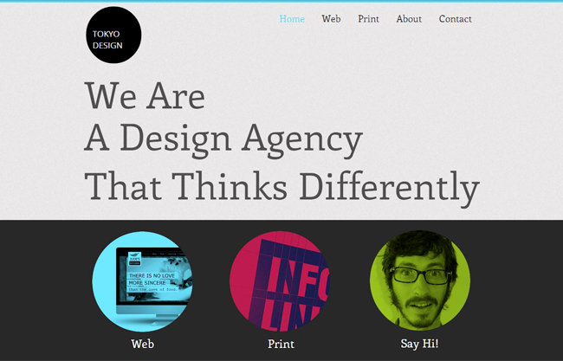
La typographie au cœur de ce modèle Wix

Skeuomorphisme – Avouez que ça a du charme !

Ce terme qui n’existe pas officiellement dans la langue française (c’est un néologisme) mais que nous croisons quotidiennement sans le savoir, mérite qu’on lui accorde quelques lignes. Le skeuomorphisme (à nos souhaits) est un style de design qui consiste à reproduire des objets physiques ou des matériaux d’apparence réaliste au sein d’une interface digitale. Le champion dans le domaine est Apple qui utilise cette technique pour nombre de ses produits. Le bloc note sur iPhone permet d’illustrer l’idée : Le fond jaune, les marges, les lignes etc. lui donnent l’aspect de l’objet en question dans les moindres détails. L’approche consiste à offrir à l’utilisateur l’utilisation la plus intuitive et naturelle possible. En 2013 le skeuomorphisme continuera probablement son ascension et nous aurons l’occasion de voir de nombreux objets réels prendre place sur la toile.
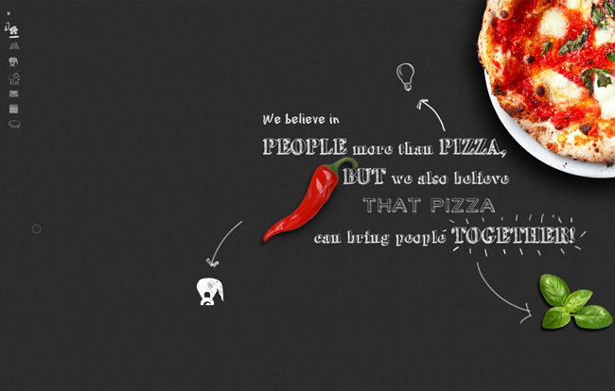
Skeuomorphisme

Metro Time

« Microsoft Design Language » alias « Metro » est une nouvelle vague visuelle qui déferle sur le web. Des combinaisons de couleurs solides, des textes ancrés dans des formes géométriques, un affichage clair, symétrique et épuré, toutes ces techniques font partie de ce langage de design. Inspirée par les symboles célèbres des transports en commun (et en partie également par le design classique suisse) cette forme d’esthétisme minimaliste permet de guider aisément l’utilisateur et de focaliser son attention sur le contenu du site.
Cette technique est visuellement à l’exacte opposée du Skeuomorphisme puisqu’elle ne présente aucun élément rappelant la vie réelle. Avec l’arrivée de Windows 8, il peut être judicieux de surfer sur cette tendance qui risque fort de continuer sur sa lancée.
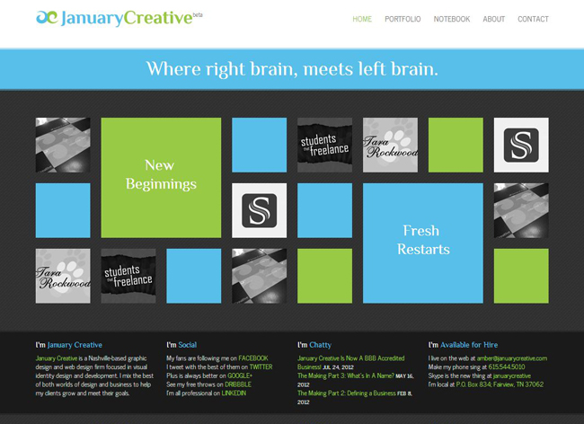
Le site de JanuaryCreative - Un exemple de Metro design

L’inspiration de Pinterest

La popularité grandissante de Pinterest est un phénomène dont l’influence sur le web design est considérable. En effet, l’aspect propre, ordonné et dynamique du réseau a séduit de nombreux designers. L’une des caractéristiques à souligner de cette tendance est la netteté de l’arrangement des éléments visuels au sein de l’espace. Tous présentent la même largeur tans dis que la hauteur uniquement varie. Cette organisation permet d’optimiser l’utilisation de l’espace visuel et de présenter le contenu – essentiellement composé d’images- avec clarté, tout en mettant le texte en valeur. Sachant que le réseau Pinterset continue de se développer, cette technique de design a probablement encore de beaux jours devant elle.
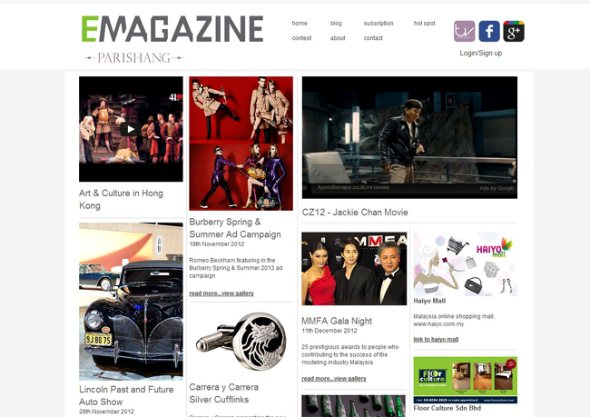
Un site Wix inspiré du style Pinterest

Photographies et illustrations personnalisées

Les clichés des images libres de droits deviennent à la longue quelque peu lassants. Des photos authentiques et innovantes sont vitales afin de réussir le design de votre site. Vous pouvez par exemple exposer des photos de votre équipe, de votre lieu de travail (mis à part l’originalité de la chose, les clients aiment savoir qu’il existe des personnes de chair et d’os derrière les murs virtuels des entreprises), ou encore de clients qui utilisent vos produits. Des dessins ou des illustrations feront également l’affaire, d’autant plus que le mélange digital/manuel ne vieillit jamais. En 2013 exposez votre créativité en images !
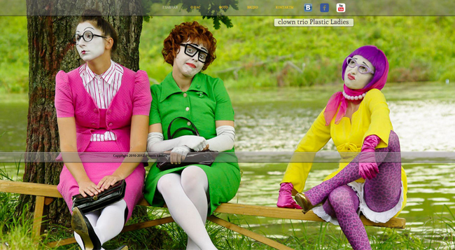
Le site Wix des "Plastic Ladies"

Six Expected Web Design Trends in 2013
Posted by Ali Qayyum | 30 Comments
Advertisement
We all know that technology and the virtual world are constantly evolving. Before you know there is a new trend in the market when it comes to web designing.As a web designer, you should be constantly striving to find the latest and trendy ways to improve the entire look of your website If you really want to see how much the web designing industry has progressed, view your website page which was four or five years back and you will be amazed to witness the obvious peculiarity between the old ones and the modern ones. Earlier, the trend was to focus more on media capabilities but now as per the new trends it is all about usability and latest stylish looks.

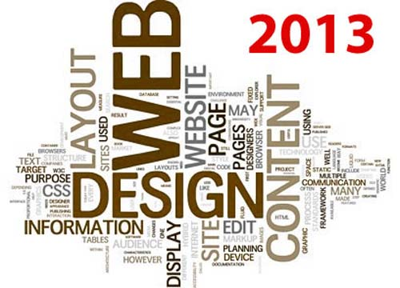
It is not easy to predict trends for an industry which is changing with the blink of any eye. You never know what is going to be in and what is going to out from the trend list by 2013 arrives. As a designer, you have a lot more responsibility to handle in this transition period. On one hand you will be designing websites to please clients by following trends set in 2012 and on another hand, you will be designing stuff in a way so that you can set new trends for 2013. Today, in this article we will discuss some of our predictions as far as web design trends in 2013 are concerned.
Advertisement
Tip : Top 15 Web Design Trends of 2012

Prediction #1 – Responsive Web Design:
This prediction is expected to turn out absolutely true as we all know that new kind of desktop and mobile devices are being introduced in the market every now and then. Our Each device, be it desktop or mobile, will vary in screen size and other proportions. The reason why responsive web designing is expected to be in trends of 2013 is that designers cannot design a new design for individual website. It will not only take a lot of your time but will also cost you a fortune.
Responsive web design will eliminate all of these problems because of its ability to respond to the size of the device being used. Thanks to responsive web designs, designers will not have to make a new layout for different mobile and desktop devices. A single design will work perfectly on all devices. No would avoid this trend because this trend is expected to make things much more convenient for all the designers.

Ultimate Responsive Web Design ToolKit
This article will help designers in building a strong toolkit to make a responsive website.
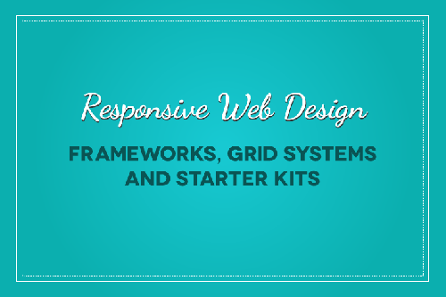

Responsive Web Design: An Ultimate Guide
This article will give you suggestions regarding long term marketing strategies for mobile responsive design.
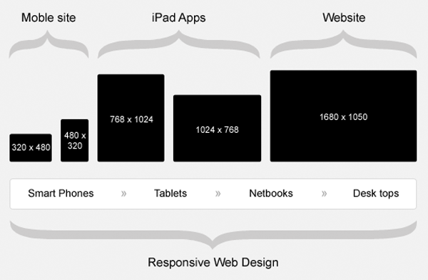

Best Responsive WordPress Themes 2012
The quality of these Responsive WordPress Themes is excellently good in real sense as this is what matters the most. You can have a quick look for selecting the designs for your device.
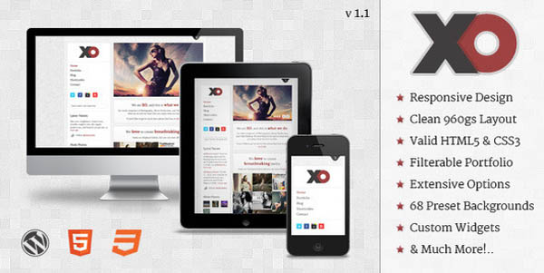

Prediction #2 – Designed Typography:
Thanks to the variations available in Typography, designers have a lot of fonts available to select from. However, selecting typography is no longer a small decision and selecting a trendy typography design is very important. Our prediction is that 2013 is going to be the year of typography as it will be given much, much importance. In fact, typography will become an integral part of any website’s design. Designers will no longer replace text with the beautiful images and will try to enhance website’s beauty through typography. By 2013, it is expected that designers will give typography a lot of importance because it is considered to be the foundation of any website.

A Collection of Beautiful Typography
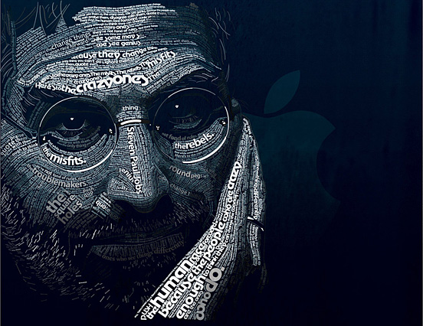

25 Fresh Typography Free Fonts For Your Next Designs
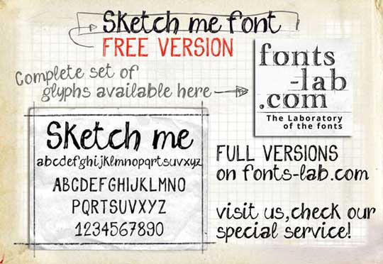

Prediction # 3 – Vertical Scrolling:
Websites’ optimization is going to be a very important decision. Nowadays, a lot of websites offer both, vertical and horizontal scrolling as far as mobile devices are concerned. However, vertical scrolling will lead the trend in 2013. Vertical scrolling is easy, convenient for all the mobile users. Vertical scrolling is quite user friendly, efficient and definitely allows easy navigation. Apart from all this, another trend that is expected to hit 2013 is vertical scrolling of menus and buttons. When a user is scrolling a page down, the header menu should scroll down with it so that the user does not have to go upwards to view the menu again. Same goes for shopping carts and social buttons. Vertical scrolling will be in demand because it allows user a friendly navigation throughout the website.
Smashinghub is an example of Vertical Scrolling. you can only see scroll on vertical..its an example of Responsive Design.
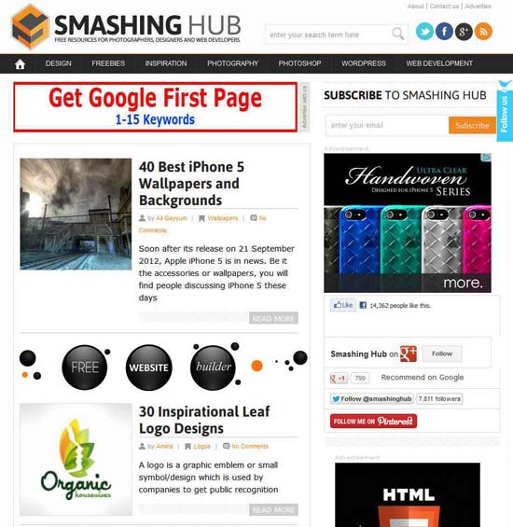

Prediction # 4 – Huge Buttons:
Since the ‘touch & tap’ is getting famous with every passing day, we can totally expect the trend of huge buttons in the upcoming year. Initially, big and huge buttons were being used just for the beautification purposes however, in 2013; they are expected to become a necessity. Huge buttons will definitely make tapping a lot easier but yes, this trend does have a flaw i.e., huge buttons would definitely require more graphics which will result into slowing down of the website. Designers will have to find a way out or else this trend might not last long. Let’s see what 2013 has in store for buttons.
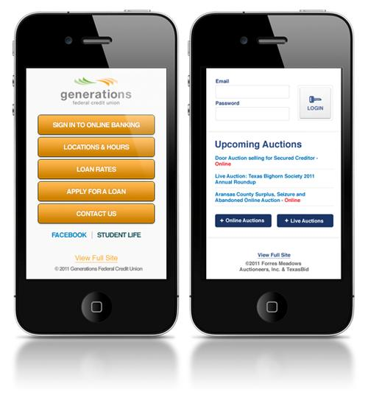

Prediction # 5 – Branding will take a hike:
We all know that businesses want their brand to be noticeable; people should be able to recognize their brand within seconds. The year to come is expected to focus more on designing the brand instead of simply designing a website pertaining to the latest trends. Designers will focus more on selecting the things that will compliment the brand itself or enhance the beauty of the logo. Designer will focus more on translating the business through the website and this trend is expected to last for a long time. It is very important for you as a business owner to get a website designed which represent your brand’s image and designers will research and give you a site exactly like this.

Prediction # 6 – Parallax Scrolling:
2013 will see a lot of increase in the usage of parallax scrolling effects. This thing has been in the industry for sometime but earlier it was associated with video games only. This feature will basically allow designers to control the depth of design objects on the website being designed.

Parallax Scrolling Effect in Web Design
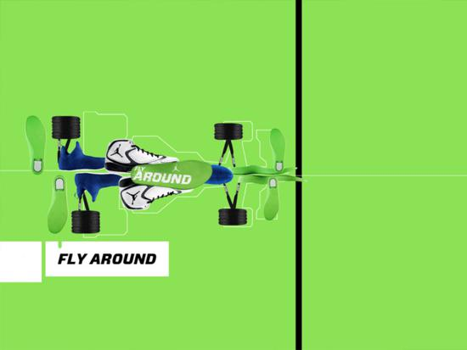

jQuery Parallax and Scrolling Effect Plugins
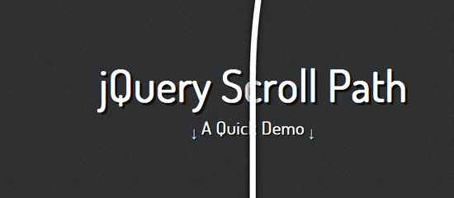

Conclusion:
Above mentioned web design trends are only predictions by some of the experts and along with these we can definitely see a lot of other trends in 2013. Are there any trends that you think will hit the designing world in 2013? If yes, please share them with us.

