Sliders in Web Design : 45 Creative Examples
October 26, 2011 - 11 Comments and 269 ReactionsWritten by Jameel Khan
Categories → Web Design,Web Inspiration
Tweet
Using slideshows or sliders within a web design is an effective method of highlighting your portfolio, projects, ecommerce products or even key site related messages and information. As the current slider trend dictates, they are typically found above the fold on the homepage.
For this article, we have found some high quality, beautifully designed and inspirational examples of sliders. Enjoy :)
You might also like…
Showcase Of Effective and Creative Pricing Page Designs →
30 Login Forms with Creative Design →
Showcase of Beautifully Designed Charts & Graphs →
20 Effective Examples of Web and Mobile Wireframe Sketches →

Backyard Burgers
Feeling hungry? Take a look at this website and choose the menu you would like to satisfy your appetite with.


Converse
A very attractive and dynamic website with loads of creatively designed and interactive slides.
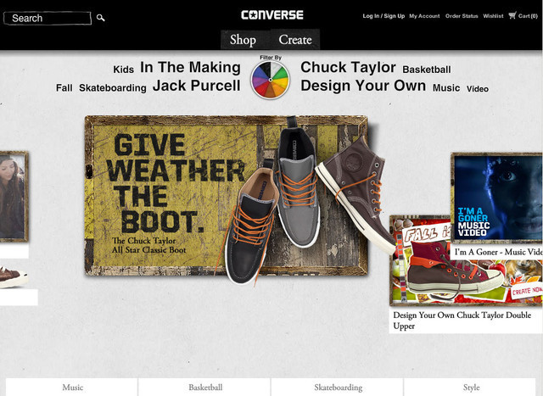

Hm Andrei
Four beautiful and visually appealing slides that change automatically or you can also change the slide by clicking the small button to view the individual slides.
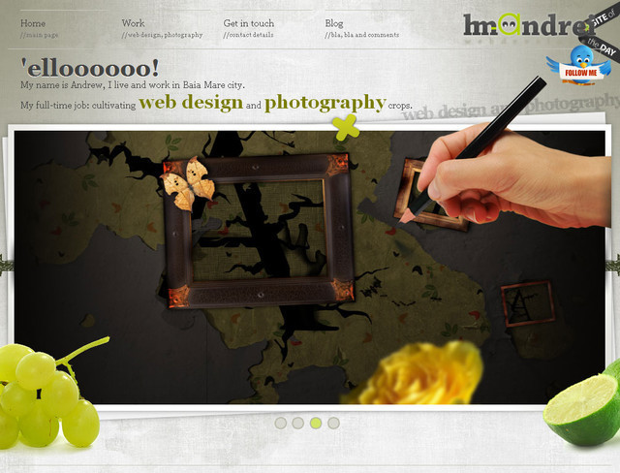

Marcs Design
The slides have been incorporated well in this design, giving the impression that they are being browsed with a laptop.
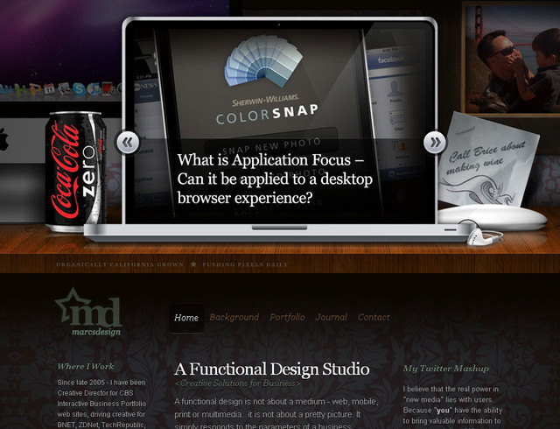

Marco Rotoli
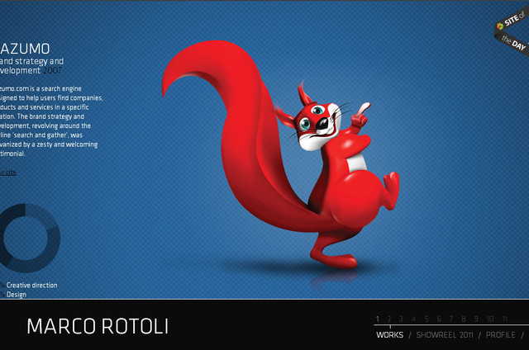

Boerdam
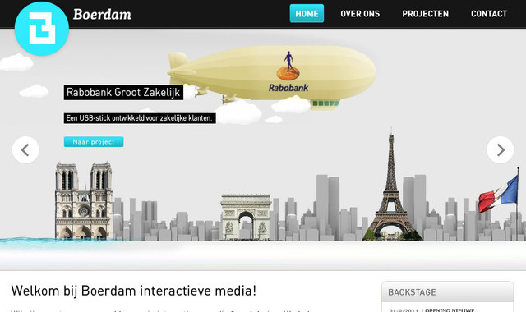

Tea Round App


These Are Things
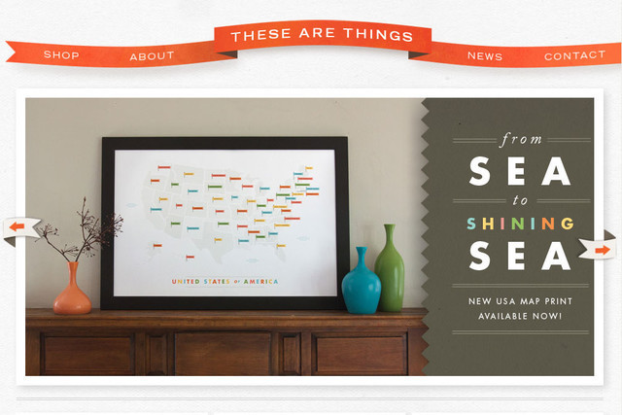

Studio XL
A vertically moving slide show with a very catchy and appealing effect. You can click the number or the arrow to view the next slide.
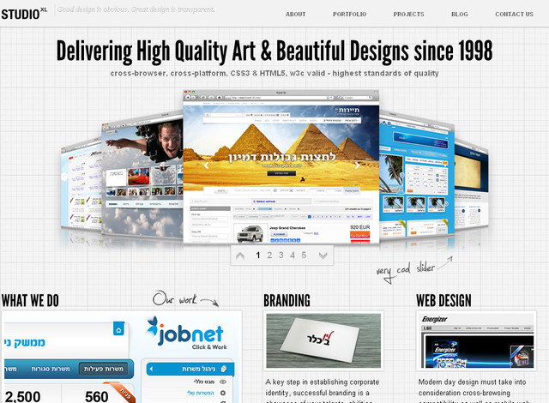

Themefuse
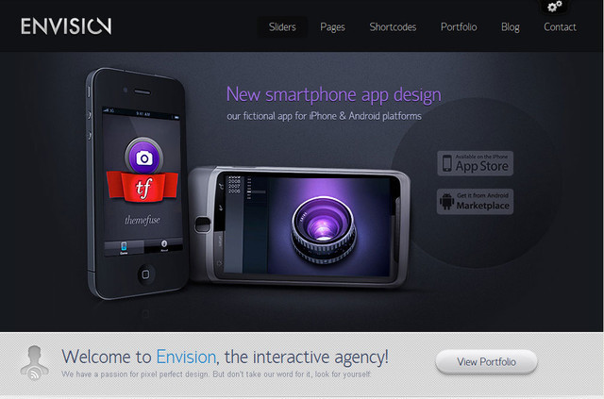

Josh Smith Design
This websites main page consists of full size slides with the navigation options presented at the bottom of the page.
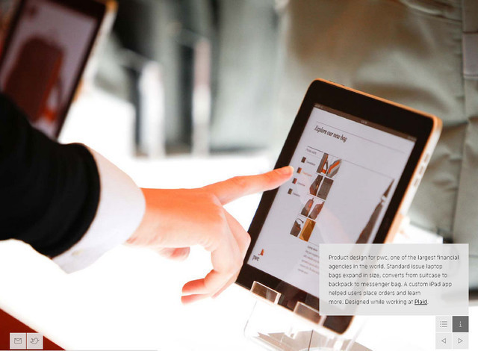

Utah travel
Lovely slideshow that is presented as a stack of photographs.
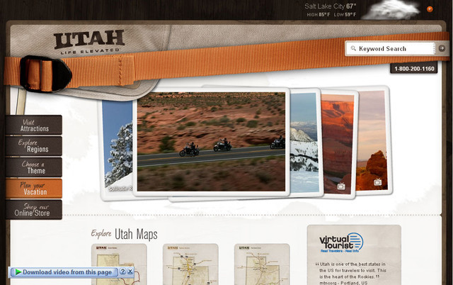

Doopsuiker Poppies
Two simple yet beautifully designed sliders at the front of this webpage.
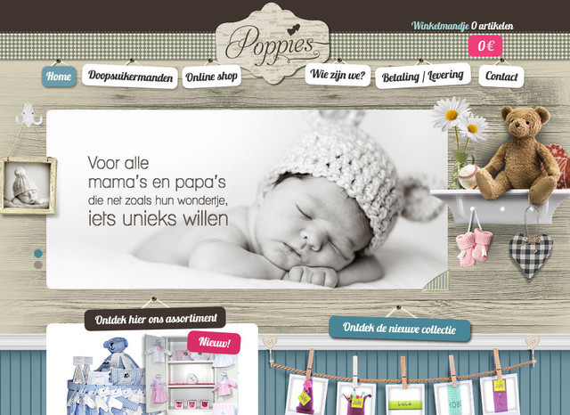

Visitphilly
Here you will see that a realistic view is presented by each individual slide that look simply amazing and attention grabbing.
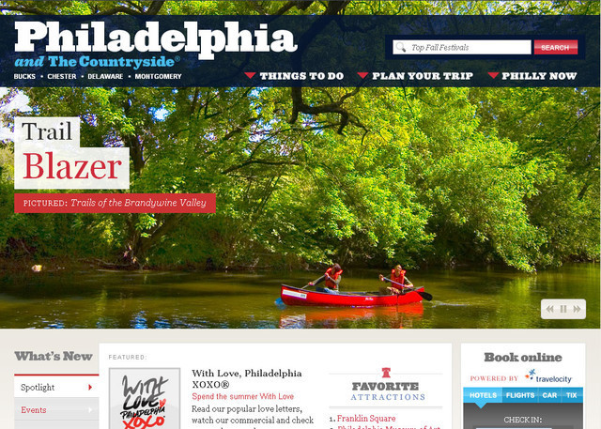

Sven Prim
A horizontal website with 42 slides that you can browse from left to right. The slide quality is truly first class.
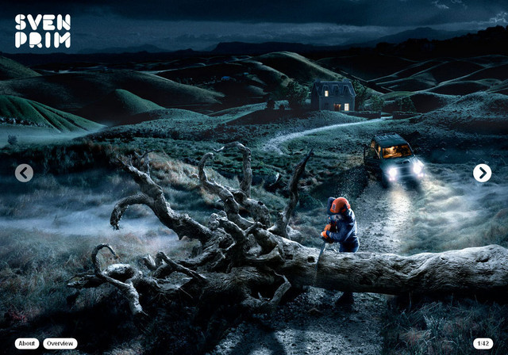

TravelBuzz
Five different and classic slides of some of the World’s most beautiful places. Click on a small thumbnail to view its enlarged view.
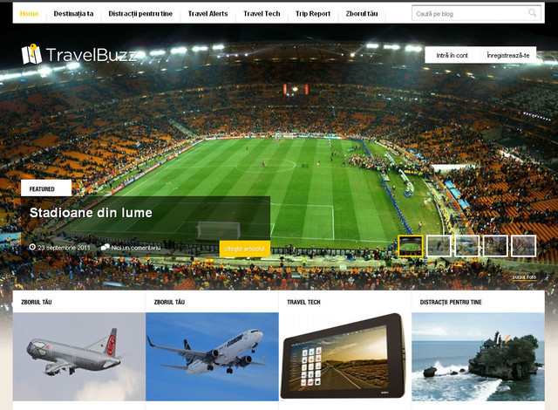

Wearesignals
A dark themed website with four different and unique slides that highlights the key points about this website.
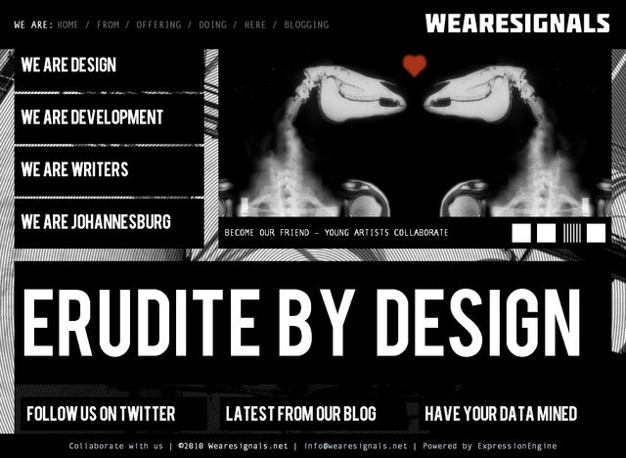

Espressoa Partments
The slides of the apartments change dynamically and gives a great overview of how each apartment looks.
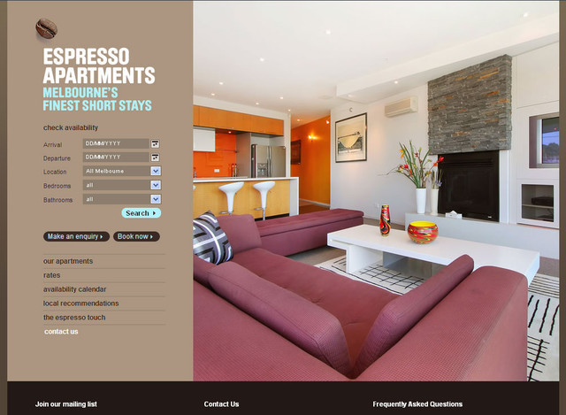

Malcolm Reading
Here the slides change vertically one by one. They specialize in the arts, museums and public realm.
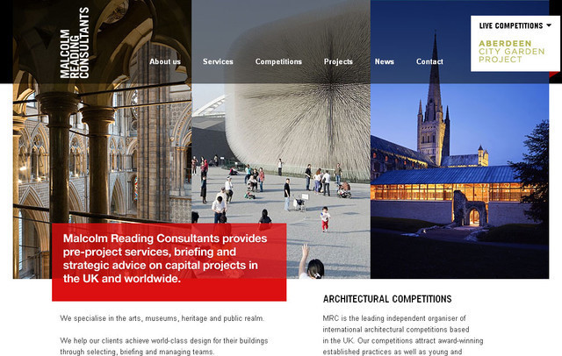

Rottefella
A very interactive website that presents the slides in a totally different manner and allows you to browse further.
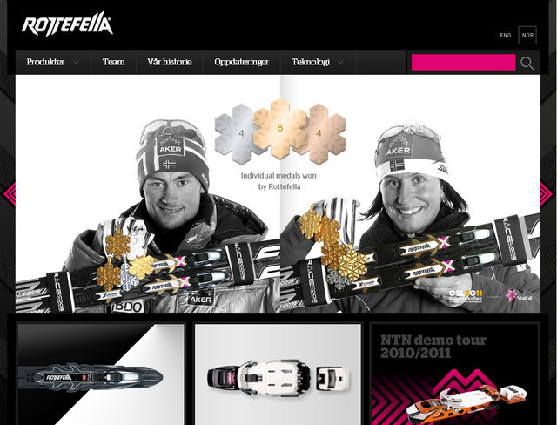

Jax Vineyards
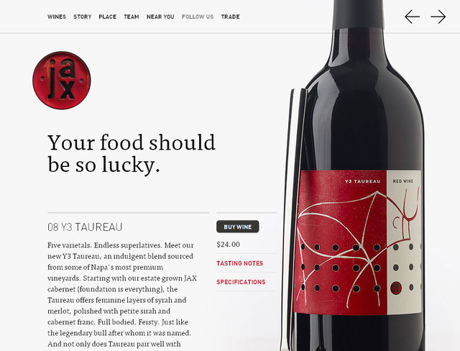

Relogik
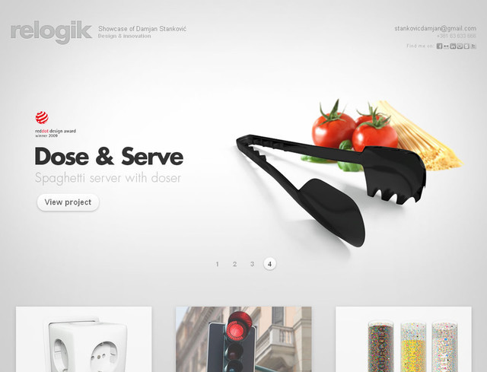

Full Fat Studios


Nealite
A French website showcasing the key points through different well designed slides.
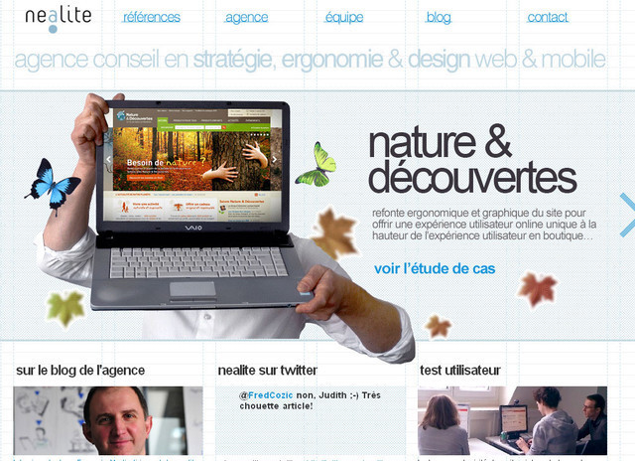

Slidedeck
New to the website? Simply check out the slides and you will get the idea what the website is all about and what it offers.
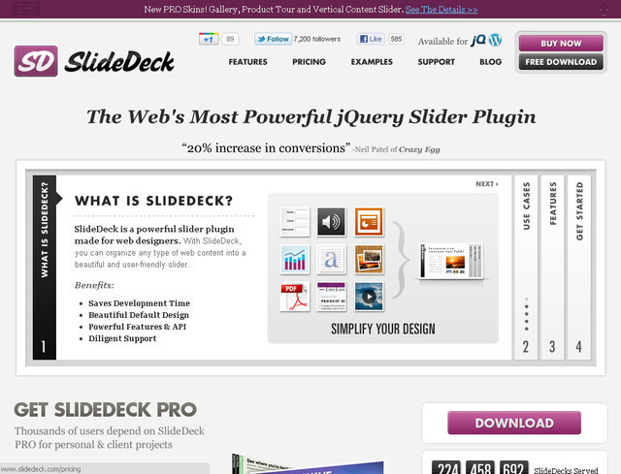

Design Royale
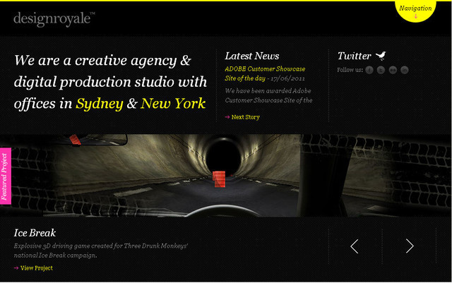

Purple Rock Scissors


La Masa Mimatta
Very colorful and beautifully designed slides that integrate with the website very well.


Fox Classics
The things that set this website apart are its high quality graphics and collection of images for the slides.


Charlie Gentle
Here the slides are divided in two section with arrows placed at the centre to navigate. When you click the arrow, both the slides move simultaneously.
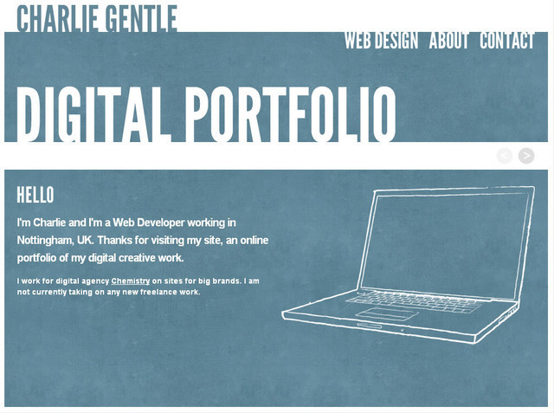

Team Viget
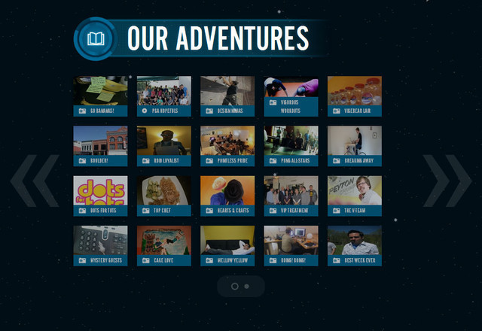

Galan Design
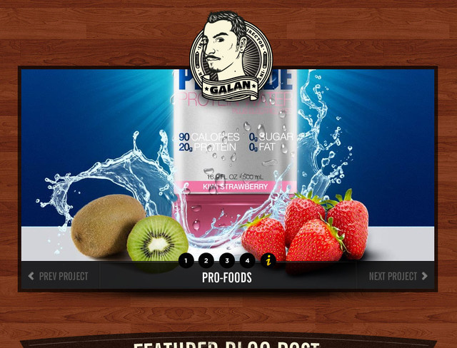

Yozenn
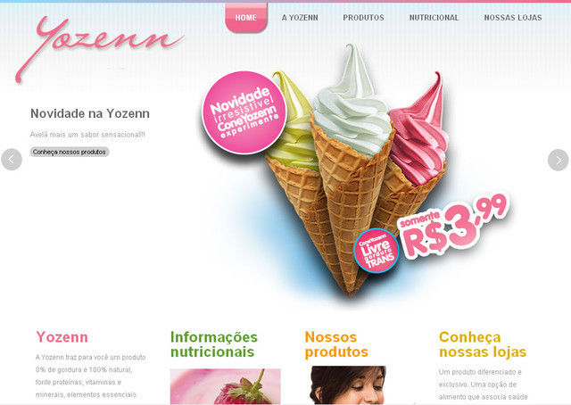

Studio Break Fast
An extremely interactive website that demonstrates the slides in a completely different mode and allow you to browse further.
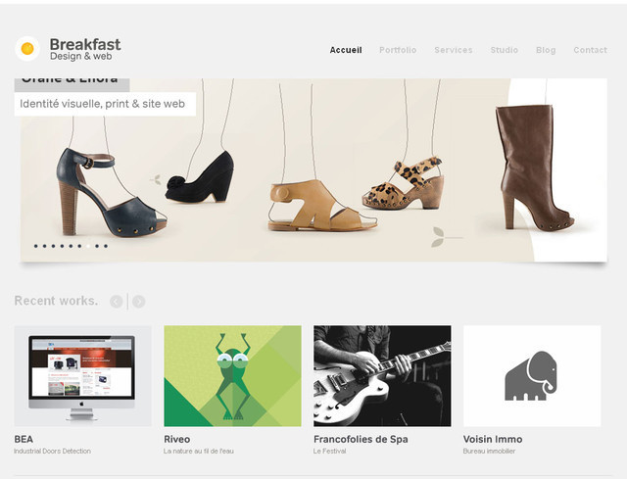

Household Design
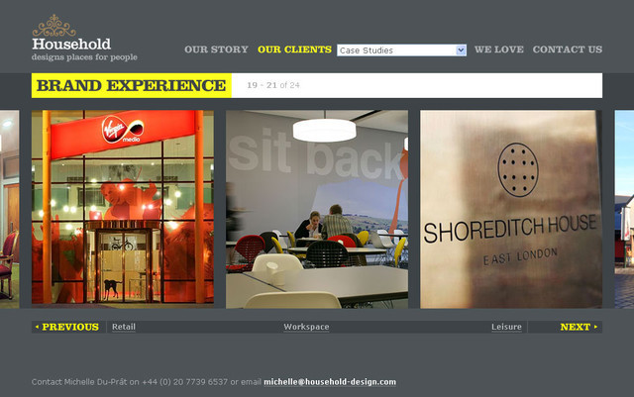

Print Mornyc
The website of Print Mor NYC highlights their printing excellence in their slides. Simply click the arrow to move to the next slide.
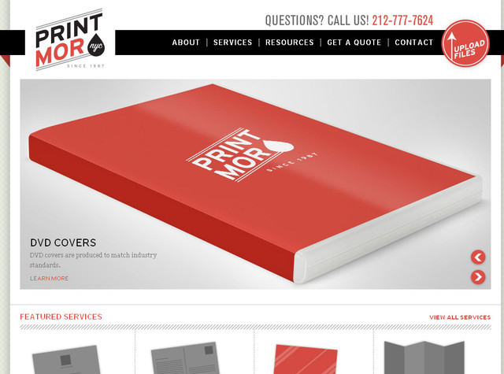

Hwo Architects
The slides move vertically giving you an idea of what you can expect from the website.
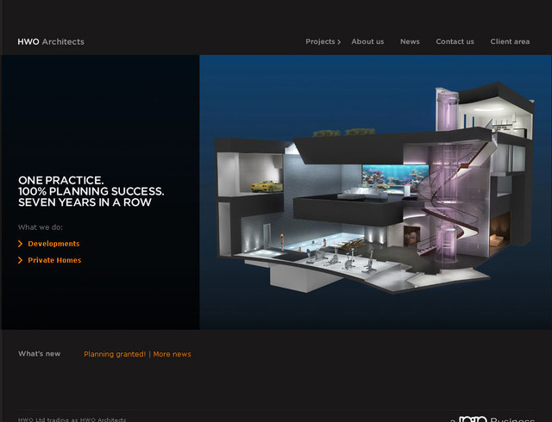

Grunnarbeid
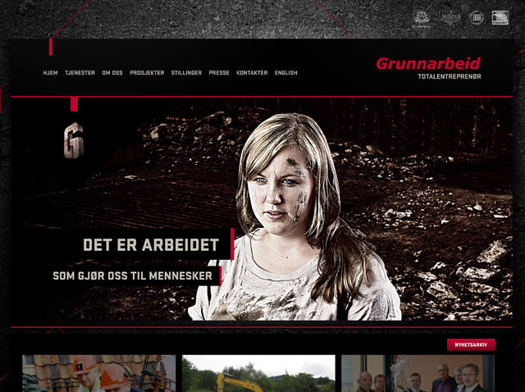

Glitz Photography
Exceptionally colorful slides that incorporate with the website incredibly well.
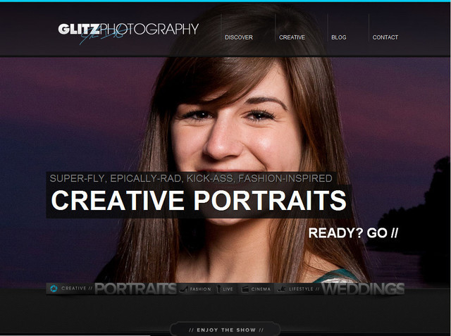

DFANY
This is what the slide show of a mobile development website should be.
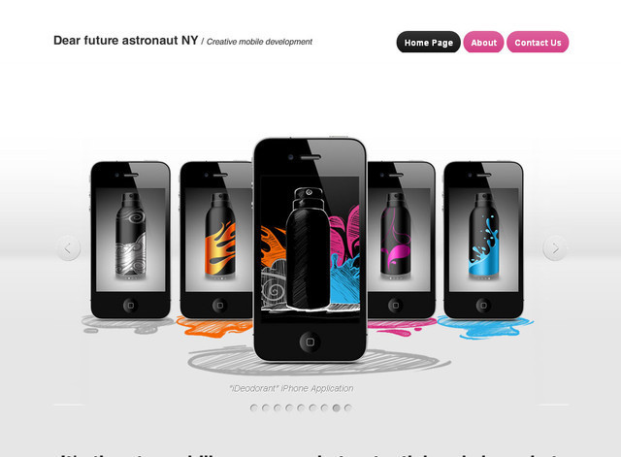

Style and Conscience
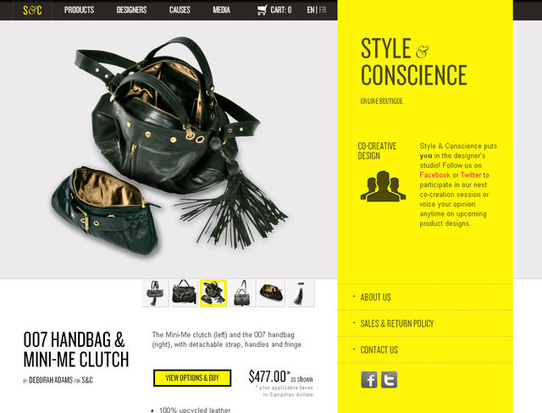

Bohemia Design
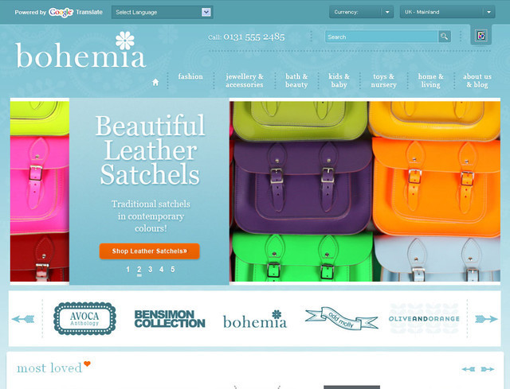

Edit Studios
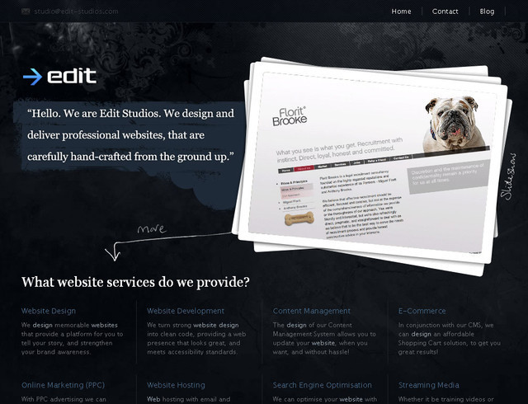

Threadless


Dconvulsions


