Introduction
Opacity Masks and Clipping Paths are two of the most used tools in my workflow. They allow me to easily reveal or hide artwork without deleting any paths. As in all digital arts, it’s best to design your workflow to allow for maximum editability. It is inevitable that either myself or the client will change their mind through the process and this technique allows for easy revisions and edits, leading to less stress and happier clients.
First let’s define the difference between a Clipping Path and an Opacity Mask:
- Clipping Paths are Binary (on or off) operations applied against all paths/objects within a layer. This can even include sub-layers with separately defined Clipping Paths.
- Opacity Masks are gray-scale Maps applied against individual paths/objects only. The only exception is that an Opacity Mask may be applied against a set of objects if they are Grouped.
It may be easier to understand with this simple example:
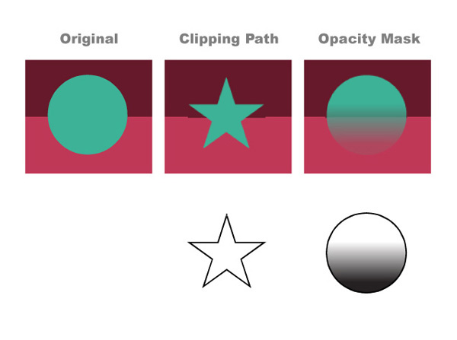
To the left is the original art with no opacity or clipping applied.
In the middle I have applied a star shaped Clipping Path to the layer containing the turquoise circle path, shown below. Because Clipping Paths is a yes or no concept, the operation only recognizes if there is or if there is not a path. The circle is revealed where there is a path, and hidden in the absence of that path.
To the right I have applied an Opacity Mask to the turquoise circle path. Because Opacity Masks recognize the full range of black to white, I used a gradient to show the range of values between full opacity and no opacity, something we will do again in just a bit. Of course we can create Opacity Masks of any solid shade of gray to assign different percentages of transparency/opacity. The default settings for Opacity Masks are: white is visible, black invisible, all the grays in-between relate accordingly.

Part 1: Clipping Paths
Clipping Paths are a great tool – I use them for 2 primary reasons:
- Cropping an entire piece of artwork to the Destination. Many times I will have artwork that extends well beyond the dimensions desired for the illustration, but I Clip the artwork to the correct dimensions plus the appropriate bleed.
- Revealing patterns, textures, or backgrounds within an area (and thus excluding it in other areas) without deleting any paths or objects

Step 1
For this demonstration I’m going to Clip the below background to a specific shape. Both the turquoise and the jellyfish are in the same Layer.
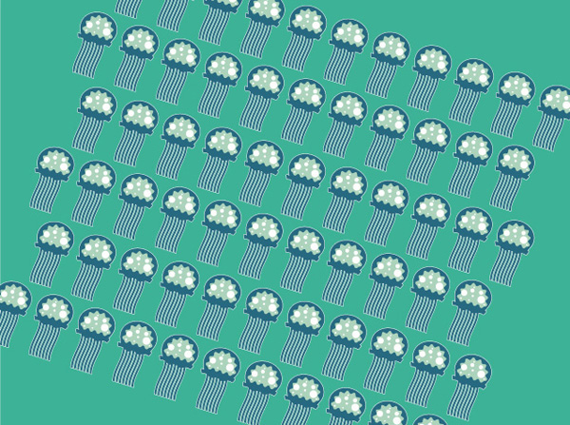

Step 2
Now we need to create a path or shape to Clip to. This example is similar to what I might do for a small spot illustration. Rectangles are so boring and predictable, let’s do something organic. So that you can easily see it, I’ve set the shape I want to clip as solid black. I usually draw this path unfilled, with a thin stroke so that I can see beneath it for accuracy.
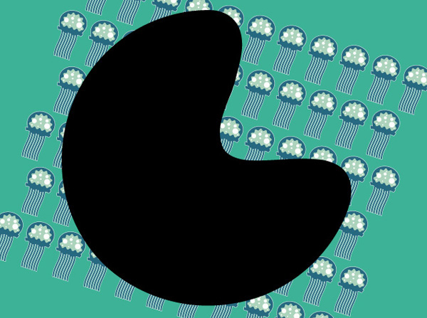

Step 3
If the Path you want to clip the layer to is not at the top of the layer set, move it there and click on the Make/Release Clipping Mask button at the bottom of the Layers panel. The Icon shows an outlined circle and square with their union shaded in. Be sure to select the layer that you want to apply the Clipping Path to, in this example it is “Layer 2,” not the path itself.
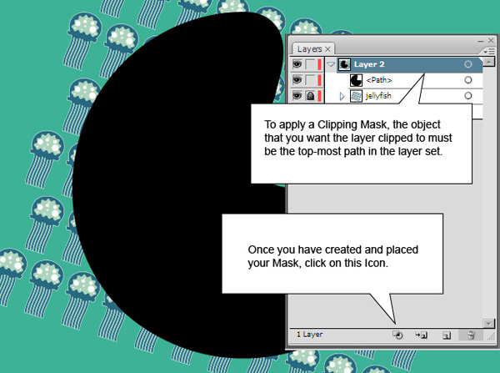
Now once the Clipping Path is applied, you can see the results. Only the artwork directly beneath the Path is revealed.
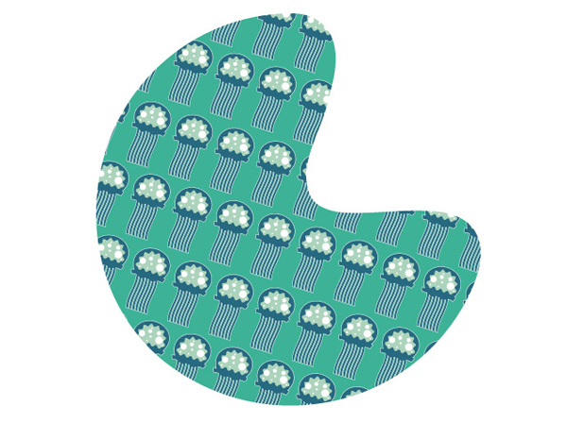
At any point you can always grab the Path and move it around if you want. Many times your Clipping Path may not be perfectly aligned so it’s nice to have the ability to nudge stuff around. Even the shape itself isn’t permanent – you can edit the individual control points! You can release the Clipping Path by selecting the Clipping Path and clicking on the same icon that created it in the Layers panel, or to completely remove it you can drag the path into the Trashcan in the Layers panel.

Part 2: Opacity Masks

Step 1
I’ve placed a simple JellyFish character in front of our freshly Clipped background. We are going to add some spots to the Jellyfish that will fade as they near his eyes and mouth. I’ve outlined the spots here at first so you can see where they overlap the white background.
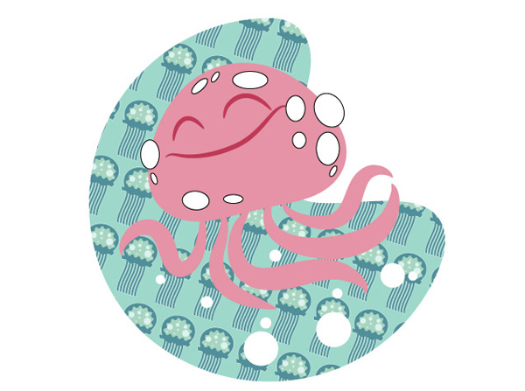

Step 2
Now I have selected the body of the Jellyfish and copied it and Pasted in Front. I then applied a simple gradient through the Gradient panel. You can see this shape below, we are going to use this as the Opacity Mask.
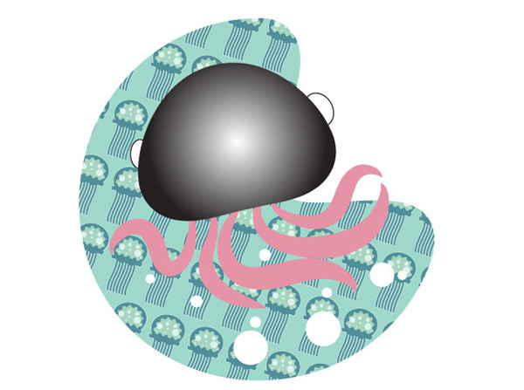

Step 3
I then Cut the new gradient shape to remove it from the artwork, keeping it in the Clipboard for use in just a minute. After selecting the white dots and Grouping them, I move to the Transparency panel and double-click in the blank area next to Thumbnail of the dots.
With the path/object/group that you want to apply the Opacity Mask to selected, double-clic in the Transparency panel to activate the Mask Layer, as shown below.
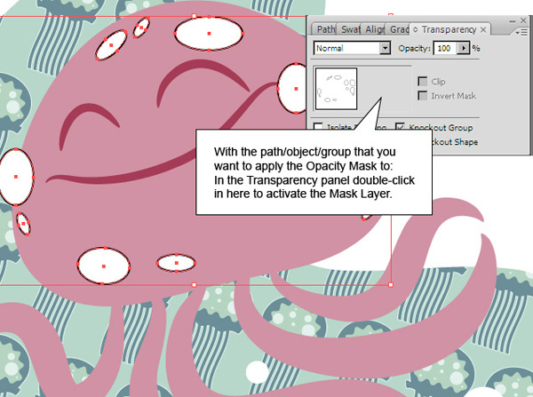

Step 4
Now that I have told Illustrator to apply an Opacity Mask to the Group of dots, I Paste in Front again (Paste in Front/Back are nice commands as they take the copied/cut paths and place them in the exact location where they came from) in this Opacity Mask area. Command + F is Paste in Front and Command + B is Paste in Back.
If you visually see the gradient on the Artboard after you paste, it means you aren’t working in the Opacity Mask area. In the Transparency panel you will notice a slight outline around either the left or right square. The left square is your Artboard artwork, the right is the Mask. It’s easy to forget if you are working on the Opacity Mask or the Artboard so make sure you are working on the correct one. When you paste into the Opacity Mask you won’t see it on the Artboard, but a preview of the shape(s) will show up in the Transparency panel, as shown below.
You will notice an icon of a Chain Link in between the two. This means if you move the artwork the Mask moves with it. If they are unlocked (by clicking on the icon) you can move the artwork independently of the Mask. This is useful if for instance you have an Opacity Mask in the shape of a shirt, but the pattern isn’t lined up correctly, you can move the pattern and the shirt stays still.
Also, notice I clicked Invert Mask in the Transparency panel. This simply changes whether black or white acts as the transparent or visible end of the spectrum and vice-versa.
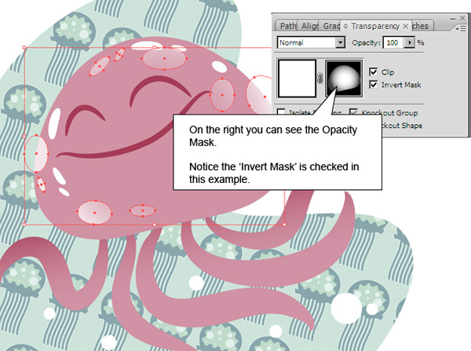

Conclusion
I move back to the Artboard and added some bright white highlights with no Mask to make the Jellyfish pop as well as toning down the background and adding a bit of gradient to the tentacles.
And here’s the finished product! Opacity Mask and Clipping Paths can free up a lot of time for an artist or designer, learn them well and they will be some of your best tools.
